**WITH NOISE AND WITHOUT FILTER**

**Image set:**

|  |
| --- |
| **Image 1:-0.1 % Noise** |

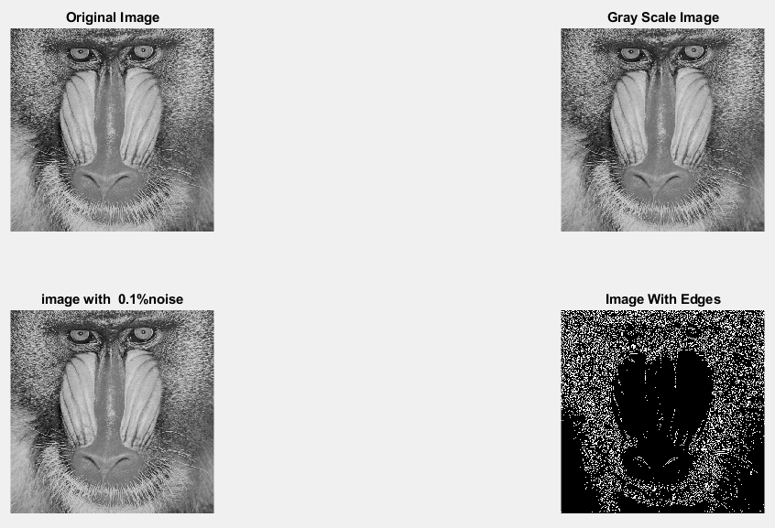

**Image 2:-10 % Noise**

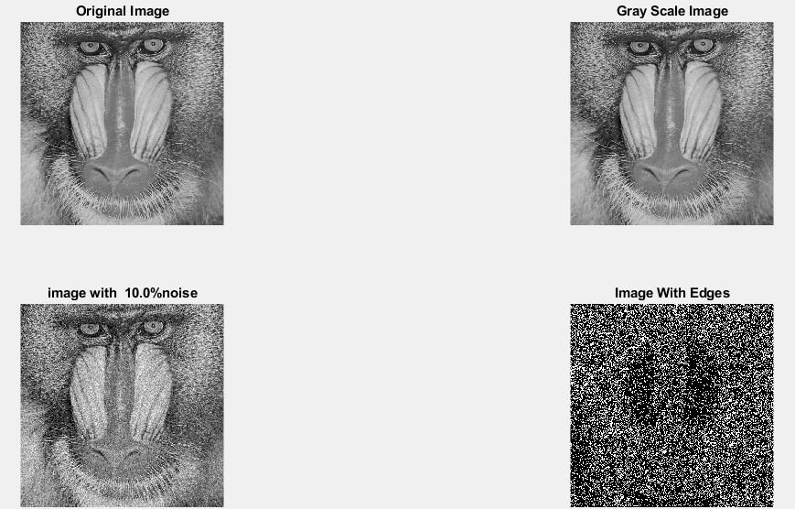

**Image 3:-20 % Noise**

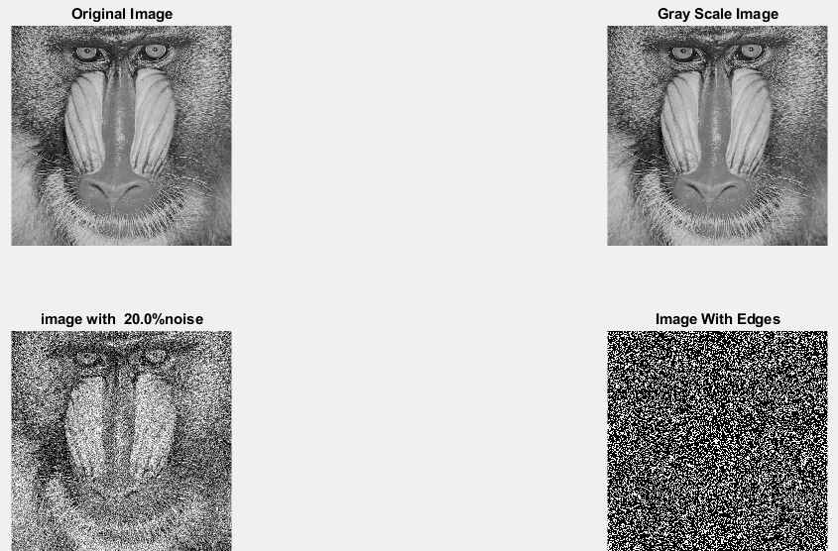

**Image 4:-30 % Noise**

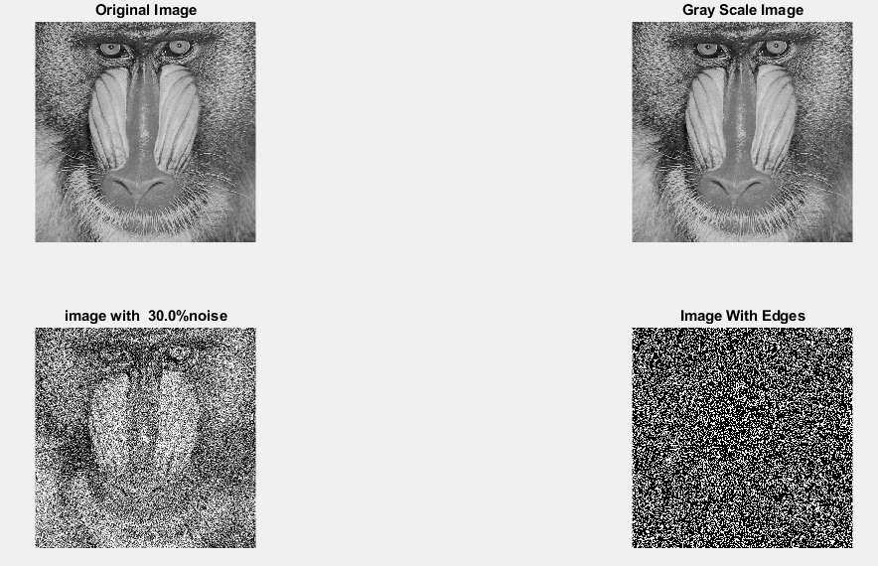

|  |
| --- |
| **Image 5:-40 % Noise** |

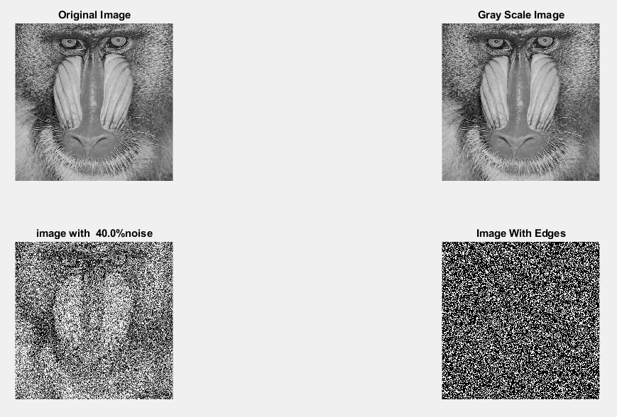

**Image 6:-50 % Noise**

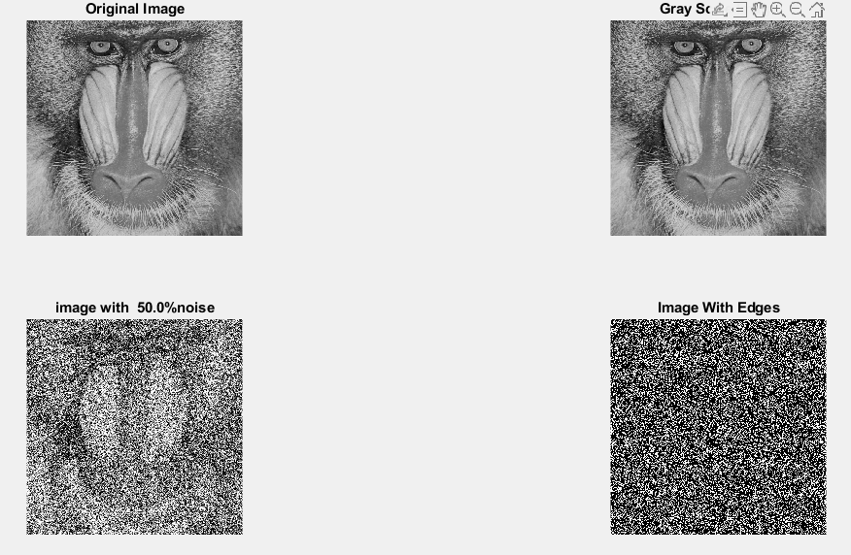

**Image 7:-60 % Noise**

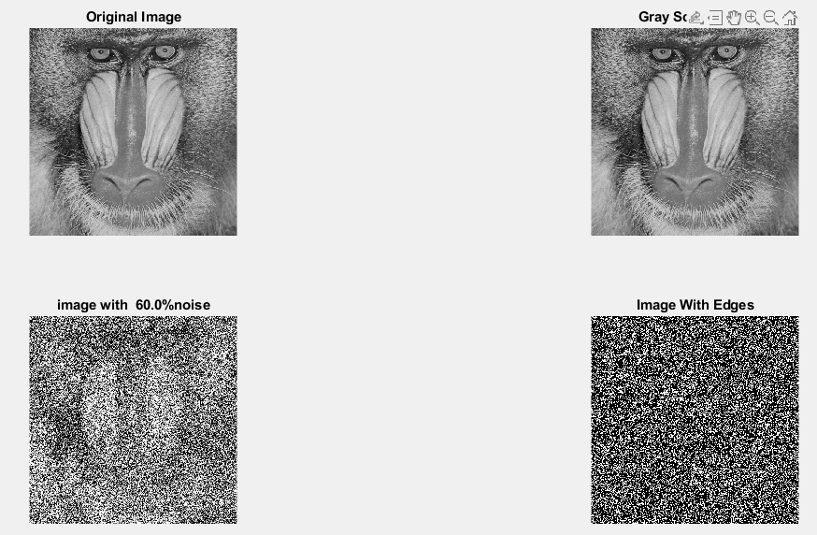

**Image 8:-70 % Noise**

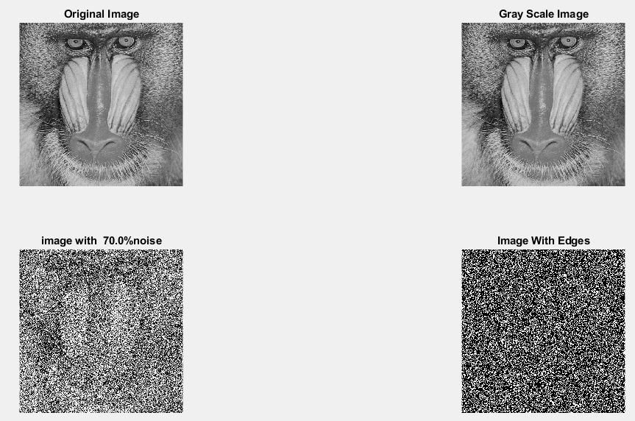

**Image 9:-80 % Noise**

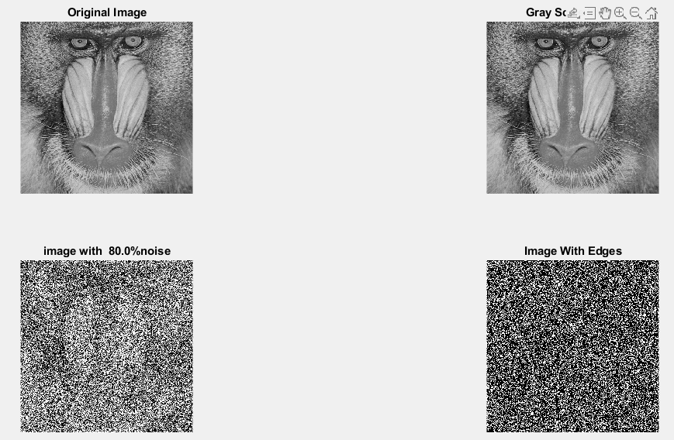

**DATA FILES**

**Image 1:-Noise0.1**

Original image ideal values:

IM1 image entropy:6.701052e-01

IM1 image mean:0.175488

Ground truth image entropy:0.943520

Ground truth image mean:0.361012

entropy between imt and im1 :0.874356

MSE between imt and im1 :0.403305

Average Difference between imt and im1 :0.185524

Maximum Difference between imt and im1 :1.000000

True Positive values:17458.000000

False Positive values: 28545.000000

True Negative values:138962.000000

False Negative values:77179.000000

Accuracy value: 0.596695

F Measure values:0.248265

Peak Signal-to Noise Ration value: 3.943663

Signal-to Noise Ration value: -3.132748

percentage of pixels that were correctly detected (Pco): 0.184473

The percentage of pixels that were not detected (Pnd):0.815527

the percentage of false alarm: (Pfa):0.301626

Euclidean Distance Value :17.488968

**Image 2:-Noise10**

Original image ideal values:

IM1 image entropy:8.723459e-01

IM1 image mean:0.292828

Ground truth image entropy:0.943520

Ground truth image mean:0.361012

entropy between imt and im1 :0.818471

MSE between imt and im1 :0.440994

Average Difference between imt and im1 :0.068184

Maximum Difference between imt and im1 :1.000000

True Positive values:27898.000000

False Positive values: 48865.000000

True Negative values:118642.000000

False Negative values:66739.000000

Accuracy value: 0.559006

F Measure values:0.325531

Peak Signal-to Noise Ration value: 3.555671

Signal-to Noise Ration value: -0.909090

percentage of pixels that were correctly detected (Pco): 0.294790

The percentage of pixels that were not detected (Pnd):0.705210

the percentage of false alarm: (Pfa):0.516341

Euclidean Distance Value :28.502051

**Image 3:-Noise20**

Original image ideal values:

IM1 image entropy:9.129677e-01

IM1 image mean:0.328094

Ground truth image entropy:0.943520

Ground truth image mean:0.361012

entropy between imt and im1 :0.801304

MSE between imt and im1 :0.454685

Average Difference between imt and im1 :0.032917

Maximum Difference between imt and im1 :1.000000

True Positive values:30726.000000

False Positive values: 55282.000000

True Negative values:112225.000000

False Negative values:63911.000000

Accuracy value: 0.545315

F Measure values:0.340181

Peak Signal-to Noise Ration value: 3.422892

Signal-to Noise Ration value: -0.415221

percentage of pixels that were correctly detected (Pco): 0.324672

The percentage of pixels that were not detected (Pnd):0.675328

the percentage of false alarm: (Pfa):0.584148

Euclidean Distance Value :31.488086

**Image 4:-Noise30**

Original image ideal values:

IM1 image entropy:9.163406e-01

IM1 image mean:0.331390

Ground truth image entropy:0.943520

Ground truth image mean:0.361012

entropy between imt and im1 :0.799487

MSE between imt and im1 :0.455761

Average Difference between imt and im1 :0.029621

Maximum Difference between imt and im1 :1.000000

True Positive values:31017.000000

False Positive values: 55855.000000

True Negative values:111652.000000

False Negative values:63620.000000

Accuracy value: 0.544239

F Measure values:0.341768

Peak Signal-to Noise Ration value: 3.412629

Signal-to Noise Ration value: -0.371811

percentage of pixels that were correctly detected (Pco): 0.327747

The percentage of pixels that were not detected (Pnd):0.672253

the percentage of false alarm: (Pfa):0.590203

Euclidean Distance Value :31.795366

**Image 5:-Noise40**

Original image ideal values:

IM1 image entropy:9.198960e-01

IM1 image mean:0.334942

Ground truth image entropy:0.943520

Ground truth image mean:0.361012

entropy between imt and im1 :0.795493

MSE between imt and im1 :0.454475

Average Difference between imt and im1 :0.026070

Maximum Difference between imt and im1 :1.000000

True Positive values:31651.000000

False Positive values: 56152.000000

True Negative values:111355.000000

False Negative values:62986.000000

Accuracy value: 0.545525

F Measure values:0.346974

Peak Signal-to Noise Ration value: 3.424896

Signal-to Noise Ration value: -0.325516

percentage of pixels that were correctly detected (Pco): 0.334446

The percentage of pixels that were not detected (Pnd):0.665554

the percentage of false alarm: (Pfa):0.593341

Euclidean Distance Value :32.464669

**Image 6:-Noise50**

Original image ideal values:

IM1 image entropy:9.233770e-01

IM1 image mean:0.338501

Ground truth image entropy:0.943520

Ground truth image mean:0.361012

entropy between imt and im1 :0.793798

MSE between imt and im1 :0.455997

Average Difference between imt and im1 :0.022511

Maximum Difference between imt and im1 :1.000000

True Positive values:31918.000000

False Positive values: 56818.000000

True Negative values:110689.000000

False Negative values:62719.000000

Accuracy value: 0.544003

F Measure values:0.348121

Peak Signal-to Noise Ration value: 3.410376

Signal-to Noise Ration value: -0.279611

percentage of pixels that were correctly detected (Pco): 0.337268

The percentage of pixels that were not detected (Pnd):0.662732

the percentage of false alarm: (Pfa):0.600378

Euclidean Distance Value :32.746649

**Image 7:-Noise60**

Original image ideal values:

IM1 image entropy:9.259424e-01

IM1 image mean:0.341179

Ground truth image entropy:0.943520

Ground truth image mean:0.361012

entropy between imt and im1 :0.790594

MSE between imt and im1 :0.454853

Average Difference between imt and im1 :0.019833

Maximum Difference between imt and im1 :1.000000

True Positive values:32419.000000

False Positive values: 57019.000000

True Negative values:110488.000000

False Negative values:62218.000000

Accuracy value: 0.545147

F Measure values:0.352237

Peak Signal-to Noise Ration value: 3.421289

Signal-to Noise Ration value: -0.245389

percentage of pixels that were correctly detected (Pco): 0.342562

The percentage of pixels that were not detected (Pnd):0.657438

the percentage of false alarm: (Pfa):0.602502

Euclidean Distance Value :33.275567

**Image 8:-Noise70**

Original image ideal values:

IM1 image entropy:9.297746e-01

IM1 image mean:0.345272

Ground truth image entropy:0.943520

Ground truth image mean:0.361012

entropy between imt and im1 :0.789699

MSE between imt and im1 :0.457886

Average Difference between imt and im1 :0.015739

Maximum Difference between imt and im1 :1.000000

True Positive values:32558.000000

False Positive values: 57953.000000

True Negative values:109554.000000

False Negative values:62079.000000

Accuracy value: 0.542114

F Measure values:0.351697

Peak Signal-to Noise Ration value: 3.392429

Signal-to Noise Ration value: -0.193596

percentage of pixels that were correctly detected (Pco): 0.344030

The percentage of pixels that were not detected (Pnd):0.655970

the percentage of false alarm: (Pfa):0.612371

Euclidean Distance Value :33.422485

**Image 9:-Noise80**

Original image ideal values:

IM1 image entropy:9.313638e-01

IM1 image mean:0.347004

Ground truth image entropy:0.943520

Ground truth image mean:0.361012

entropy between imt and im1 :0.788441

MSE between imt and im1 :0.458130

Average Difference between imt and im1 :0.014008

Maximum Difference between imt and im1 :1.000000

True Positive values:32753.000000

False Positive values: 58212.000000

True Negative values:109295.000000

False Negative values:61884.000000

Accuracy value: 0.541870

F Measure values:0.352938

Peak Signal-to Noise Ration value: 3.390114

Signal-to Noise Ration value: -0.171866

percentage of pixels that were correctly detected (Pco): 0.346091

The percentage of pixels that were not detected (Pnd):0.653909

the percentage of false alarm: (Pfa):0.615108

Euclidean Distance Value :33.628392